Inspirations
Poetry and Creative Writing Competition

The Atkinson, in partnership with The Arts Society Southport, would like to invite anyone with links to the Sefton Borough to take part in a new Poetry and Creative Writing Competition. Responding to artworks featured in an upcoming exhibition at The Atkinson, you are invited to submit one entry with a maximum of 1000 words. You can read the full brief below.

Please email your competition entries to jemma.tynan@sefton.gov.uk by end of Sunday 2 May 2021. Postal entries to; Jemma Tynan, The Atkinson, Lord Street, Southport, PR8 1DB.

All entries will be exhibited on The Atkinson’s website from Saturday 8 May 2021 in the following categories: Age 11 and under. Age 12-18. Age 19-25. Age 25 and over. The winners will be announced on Saturday 22 May 2021 and awarded prizes donated by The Arts Society Southport.

View the competition online here:
theatkinson.co.uk/whats-on/online-exhibitions/inspirations-competition

Brief – Inspired by ‘Natural High’

Curated from The Atkinson’s fine art collection, a new exhibition exploring the wonderful scenery of Great Britain, ‘Natural High’, will open in June 2021. The exhibition themes are The Lake District, Scotland, Wales, Pastoral Scenes and The Coast. For the competition, five artworks from the upcoming exhibition have been selected as inspiration for your writing. These can be found on The Atkinson website and as thumbnails below.

You are invited to submit one entry with a maximum of 1000 words that responds directly to these artworks or the theme of journeys around Great Britain. The past year has taught us to appreciate the landscape on our doorstep and explore further afield with ‘staycations’! Please use the selected artworks and themes as inspiration to see what journey your creativity takes you on. You can write about what is happening now, memories of past holidays or dreams for the future.

Freedom to get creative!

The competition is for poetry, stories, song lyrics, essays, letters, blogs, zines or any form of creative writing you can come up with. Adults may give younger residents encouragement but must not have a hands-on role in creating the work.

The Atkinson may reject entries that it considers are inappropriate for any reason. Only original works will be accepted or influences that are clearly referenced through the title, e.g. Rewritten Poem by Dylan Thomas.

Prizes

The entries will be reviewed by a panel appointed by The Atkinson. All works are judged on individual merit and the judges’ decision is final. No correspondence or discussion will be entered into. Winners will be announced on Saturday 22 May 2021. Winners will receive vouchers to be redeemed online and their work will be incorporated into the Natural High Exhibition.

If you have any queries about the competition, please contact Jemma Tynan (Exhibitions and Learning Officer, The Atkinson) jemma.tynan@sefton.gov.uk 0151 934 2033.

Inspirations

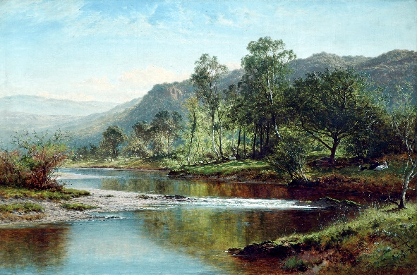  Lake District Section, River Running through Derwentwater  by Benjamin William Leader | 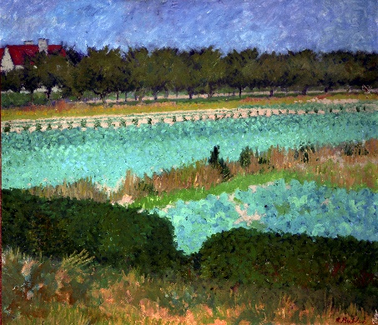  Pastoral Scenes Section, Suffolk Farm  by Robert Buhler
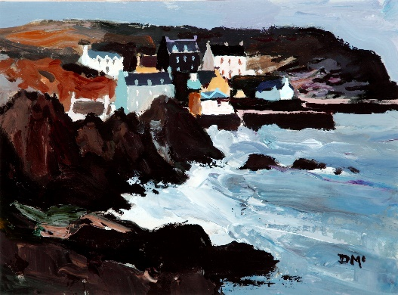  Scotland Section, Port Patrick, Scotland  by Donald McIntyre | 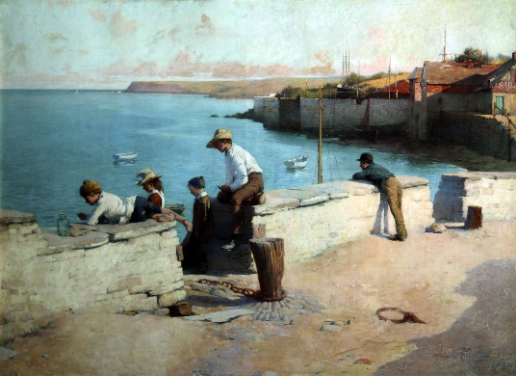  The Coast Section, Evening at Padstow  by W Llewellyn
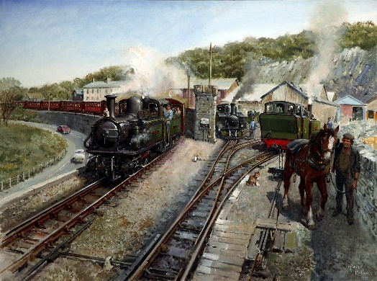  Wales Section, Ffestiniog Work Horses  by Terence Cuneo | The 5 selected artworks can also be viewed online here:  theatkinson.co.uk/whats-on/online-exhibitions/inspirations-competition

INSPIRATIONS ENTRY FORM
Competition Open 23 January 2021 – 2 May 2021

Please complete the information below. The completed form, together with a digital copy of your work if applicable, should be emailed to jemma.tynan@sefton.gov.uk by the end of the last day of submission - Sunday 2 May 2021. Postal entries to; Jemma Tynan, The Atkinson, Lord Street, Southport, PR8 1DB.

Personal Details | (Your details will only be used for this competition and not for any other reason)
Name
Age
Name of parent/guardian if under 16
Home Address

Telephone Number
Email Address
(must be that of Parent/Guardian if under 16)
Details of entry
Title
Artwork(s) used as Inspiration
Entry Style
(e.g. poem, story etc)
Entry
(Can be sent as an attachment to your email. Please title the file:
Your Name, Inspirations)

